# Scenario Analysis

## Part 1. What is Scenario Analysis? What is Scenario Analysis under Credit Risk Assessment?

1. What is Scenario Analysis?

Scenario Analysis is a strategic planning and risk management tool that involves the systematic exploration and evaluation of possible future events by considering alternative plausible outcomes. By constructing detailed and distinct scenarios, organizations can assess the potential impacts of various uncertainties and external factors on their operations, financial performance, or strategic objectives. This method enables stakeholders to anticipate challenges, identify opportunities, and develop robust strategies to navigate different future states. Unlike traditional forecasting, which often relies on a single set of assumptions, Scenario Analysis embraces a range of possibilities, enhancing an organization’s resilience and adaptability in the face of volatility and complexity.

2. What is Scenario Analysis under Credit Risk Assessment?

Scenario Analysis under Credit Risk Assessment specifically refers to the process of evaluating how different adverse economic conditions or borrower-specific events may influence the likelihood of default and the overall performance of a credit portfolio. This involves creating hypothetical but plausible scenarios, such as economic recessions, interest rate hikes, or sector-specific downturns, and analyzing their potential effects on borrowers’ ability to repay loans. By simulating these scenarios, financial institutions can identify vulnerabilities within their portfolios, estimate potential losses, and adjust their risk management strategies accordingly.

3. Purpose of Scenario Analysis in Credit Risk

The primary purpose of Scenario Analysis in Credit Risk is to enhance the robustness and resilience of financial institutions by proactively identifying and preparing for potential adverse conditions that could impact loan performance and portfolio stability. By assessing how different economic and borrower-specific scenarios affect default probabilities, loss given default, and exposure at default, institutions can better estimate potential losses and ensure adequate capital reserves. Additionally, this comprehensive evaluation supports informed decision-making, enabling institutions to manage risks more effectively, safeguard their financial health, and maintain trust with stakeholders during periods of economic uncertainty.

## Part 2. How Scenario Analysis is Solved in the Financial Industry?

Scenario analysis is an essential risk management tool in finance, allowing institutions to simulate potential outcomes under hypothetical conditions to assess risks. Traditional scenario analysis relies on predefined economic scenarios or stress tests. Scott et al. (2024) described stress testing frameworks used by financial institutions to simulate credit risk under adverse economic conditions. These methods are based on historical data and expert-defined parameters. Monte Carlo methods are extensively used to perform probabilistic scenario analysis by generating a wide range of possible outcomes based on random variation in input parameters. For example, Monte Carlo simulations are used to analyze flash crash scenarios, quantify crash severity, and explore relationships between market conditions and crash dynamics in high-frequency financial markets (Gao et al., 2022). Moreover, advanced technologies, such as Agent-Based Models (ABMs) and Generative adversarial networks (GANs) are integrated with traditional methods for richer scenario analysis. As a tool to create synthetic financial scenarios, Flaig & Junike (2023) demonstrated how GAN-based scenario generators can produce diverse hypothetical conditions for market risk modeling.

## Part 3. Limitations of Current Approaches

While scenario analysis has proven to be a valuable tool for understanding and mitigating financial risks, its effectiveness is often constrained by limitations in traditional methods, which can impact the accuracy, scalability, and adaptability of the results. Flaig & Junike (2023) highlighted the risk of underestimating market variability in traditional models. This is because traditional methods heavily depend on historical trends and fixed assumptions, which may not account for novel or extreme market conditions, such as black swan events. Similarly, predefined scenarios are often shaped by the biases of the designers and may not sufficiently explore the full spectrum of potential risks. Methods such as Monte Carlo simulations and rule-based models, while effective in generating probabilistic outcomes and conducting sensitivity analyses, are recognized by Gao et al. (2022) that often struggle to adequately capture the non-linear and interdependent risks that characterize modern financial markets. These limitations arise from inherent assumptions about parameter independence and linearity, which may not hold true in complex, dynamic market environments. Last but not least, advanced methods, including machine learning-based generators sometimes have computational intensity. For instance, the high-frequency agent-based models (ABMs), as used by Gao et al. (2022), require significant computational resources, limiting their scalability for smaller institutions.

## Part 4. How AI/ML Addresses These Limitations

These limitations in traditional approaches highlight the need for more advanced methods that can dynamically adapt to complex, non-linear relationships and interdependencies in financial markets. Machine learning emerges as a powerful solution, offering the ability to address these challenges through data-driven, flexible, and scalable techniques. In the Bitcon price estimation, Cai et al. (2022) employed machine learning techniques, including neural networks and regression analysis, in combination with what-if analysis and historical data to estimate Bitcoin price volatility under different hypothetical scenarios. This integrated approach enhanced their ability to quantify risk exposure and identify correlations among various shocks, such as policy uncertainty and market sentiment. Neural networks and gradient boosting machines, which excel in detecting complex relationships in data, outperforming traditional methods in scenarios with non-linear dependencies can help compensate for the limitation of Monte Carlo Simulations. Random Forest, as highlighted in credit risk management studies (Leo, Sharma, & Maddulety, 2019), effectively addresses class imbalance issues, a common challenge in credit risk datasets. By leveraging ensemble learning techniques, it provides robust classification performance even for underrepresented classes.

The integration of diverse data sources is another advantage brought by these machine learning algorithms, which can integrate structured and unstructured data, such as social media sentiment, economic indicators, and transactional data, providing richer insights. Furthermore, unsupervised Machine Learning techniques, like clustering and anomaly detection, are particularly effective for identifying emerging risks or unexpected events in financial markets. This ability to harness diverse data sources and detect anomalies not only enhances the depth of scenario analysis but also highlights the need for scalable solutions to handle the computational demands of high-frequency simulations. To address these demands, the cloud-Based AI integration emerges as a vital enabler, providing the scalability and efficiency required for implementing advanced machine learning frameworks in financial scenario analysis, making them accessible to smaller financial institutions (Gao et al., 2022)​. A key criticism of ML models is their "black-box" nature. However, interpretability tools such as SHAP (Shapley Additive Explanations) and LIME (Local Interpretable Model-agnostic Explanations) help reveal how input variables influence predictions. For example, credit risk models using Random Forest can apply SHAP to highlight the contribution of factors like credit limit or age to default predictions, addressing fairness concerns (Gramegna et al., 2021).

## Part 5. Landscape – Bubble Chart

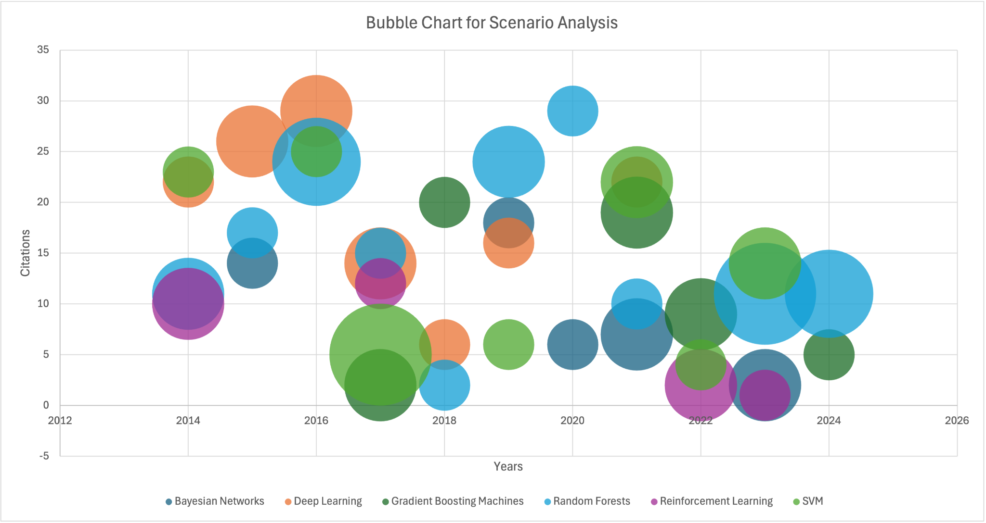

Date from:[literature review](https://docs.google.com/document/d/18vZYLrrVZACYK92JIfP2Zjg09-Bpf9jkf2B9MXaoxg4/edit?usp=sharing)

We searched 77 papers reference on the application of ML models in Scenario Analysis through Google Scholar. Random Forest is the most common application of machine learning models in Scenario Analysis. This is not only reflected in the financial field, but also in the fields of biology and environmental science. You can view link for the APA reference data of the literature review through the link at the bottom of the picture.

## Part 6. Why Random Forest and Hands On

### Why Random Forest

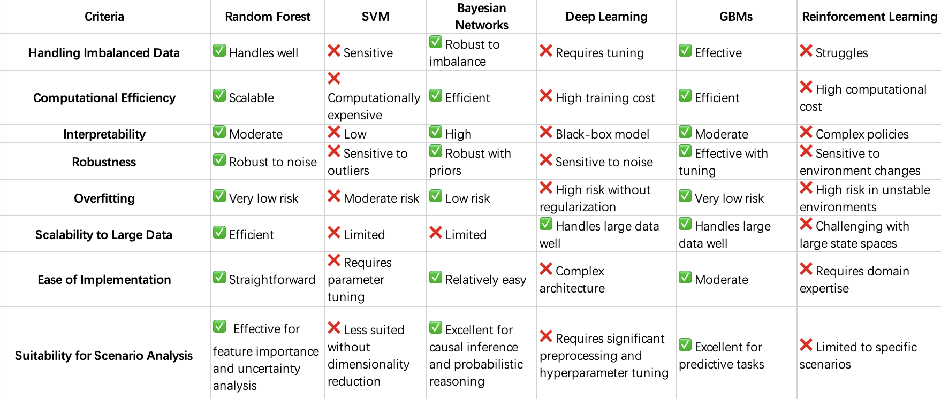

* Handles Non-Linearity: Random Forest captures complex, non-linear relationships without needing much feature engineering, outperforming simpler models like SVM.
* Reduces Overfitting: Its ensemble approach lowers the risk of overfitting, especially in small datasets, compared to Deep Learning or SVM.
* Works with Missing Data: Random Forest can handle missing data directly without extra steps like imputation.
* Easy to Use: It requires little parameter tuning, making it easier compared to complex models like Gradient Boosting or Deep Learning.
* Efficient: Random Forest is faster than Deep Learning and works well for medium-sized datasets.
* Great for Scenario Analysis: It’s robust to noisy data and identifies important features, making it perfect for scenario planning.
* Although GBMs and RF have many advantages in dealing with scenario analysis problems, Random Forest is faster, simpler, and more robust, making it ideal for quick deployment or noisy data.RF handles noisy data better due to random sampling, while GBMs may overfit noisy points.

### Hands on

**Hands-On Methodology:** The hands-on work involved building decision trees for both Normal and COVID scenarios to model default probabilities. The process started with data preprocessing, including filtering datasets based on Limit Balance, Employment Status, and Income levels. Each decision tree was constructed step-by-step using a recursive partitioning approach.

**Entropy and Information Gain Calculations:** Entropy and Information Gain were calculated at each step to determine the most informative splits. Entropy measures the disorder or uncertainty in the data, calculated using the formula: H(S) = -p1log2(p1) - p2log2(p2), where p1 and p2 are the proportions of default and non-default cases. Splitting features, such as LIMIT_BAL, INCOME, or Employment Status, reduce uncertainty by creating groups with more homogeneous outcomes.

Information Gain is used to evaluate the effectiveness of each split. It measures the reduction in entropy achieved after a split and is computed as: Gain = H(S) - Weighted sum of child entropies. The feature with the highest information gain is selected at each node, ensuring that the splits maximize the reduction in uncertainty.

**Tree Splits:** Each tree was built by evaluating features and selecting splits that provided the highest information gain. For example:

* Tree 1 split based on LIMIT_BAL and INCOME.
* Tree 2 split based on LIMIT_BAL and Employment_Status.
* Tree 3 split based on INCOME and Employment_Status.

The process was repeated for both scenarios—Normal and COVID—using datasets filtered by specific conditions, such as employment type, limit balance level or income level.

**Prediction and Ensemble Approach:** For each scenario, predictions from all three trees were combined using a majority voting approach. Each tree provided an independent classification result (0 or 1). The final prediction was determined by selecting the most frequent class across the three trees. This ensemble method improved prediction accuracy by leveraging the strengths of individual decision trees and reducing the risk of overfitting to specific patterns in the data.

Please check the [Colab file](https://colab.research.google.com/drive/1_b_30Aqtf6lisn3FYreU4uhBZgEo-Rbz?usp=sharing) for detailed hands-on work.

## Part 7. Discussion and Future Extension

### **Discussion**

The models were evaluated based on their ability to correctly classify default and non-default cases. The use of decision trees allowed for transparency in identifying key factors contributing to default risk. Insights revealed that income levels, balance limits, and employment types significantly impacted default probabilities, particularly under COVID conditions where economic instability heightened risks.

**Analysis of Results**

Scenario: Normal Observations

* The model performs very well for predicting Non-Defaults (Class 0), achieving high precision, recall, and F1-score.
* The imbalance in class distribution (28 vs 2) likely caused the model to focus heavily on the majority class, ignoring the minority class entirely.
* High accuracy (93.33%) is misleading since it reflects success in predicting the majority class but fails for the minority class.

Scenario: COVID Observations

* The model performs poorly overall, with 53.33% accuracy.
* Similar to the Normal scenario, it predicts Non-Defaults (Class 0) reasonably well.
* The performance drop in this scenario suggests that economic instability during COVID likely introduced higher variability and made predictions more challenging.
* The class imbalance (16 vs 14) is less severe compared to the Normal scenario, yet the model struggles with defaults due to lack of robust handling for class imbalance.

### **Future Extension**

However, the current model focuses only on three variables—Limit Balance, Income, and Employment Status. To improve predictive accuracy and gain a deeper understanding of the factors influencing default probability, we should incorporate additional features. Real-world credit risk scenario analysis typically includes variables such as credit history, payment behavior, and macroeconomic indicators. Incorporating these features can provide a more comprehensive analysis.

Performing additional stress tests by simulating extreme economic scenarios can help assess how default probabilities change under adverse conditions. These tests can model the impact of sudden income loss, high inflation, or interest rate hikes, offering insights into potential vulnerabilities in different economic climates.

To further enhance the model, feature engineering techniques should be applied to derive new predictors, such as the debt-to-income ratio, credit utilization rate, and loan-to-value ratios. These engineered features may capture additional nuances that influence default risk.

Advanced machine learning models, such as XGBoost, should also be explored. XGBoost is well-suited for handling class imbalance, a common issue in default prediction datasets, and can achieve higher accuracy through its gradient boosting framework. Combining these approaches with robust evaluation metrics can lead to more accurate and actionable credit risk assessments.

## Part 8. Conclusion

Scenario analysis has proven to be an indispensable tool for credit risk assessment and strategic financial planning, offering institutions a structured way to navigate uncertainties and mitigate potential threats. As explored in this paper, traditional approaches like Monte Carlo simulations and stress testing have laid the foundation for risk analysis but face limitations in handling complex, non-linear dependencies and unexpected market shifts.

The integration of machine learning (ML) techniques, such as Random Forest, neural networks, and gradient boosting, represents a significant advancement in overcoming these challenges. By leveraging vast datasets and detecting intricate patterns, ML algorithms enhance the predictive accuracy and scalability of scenario analysis, addressing key issues like class imbalance and computational inefficiency. The application of Random Forest, in particular, offers a balance of interpretability, robustness, and efficiency, making it an ideal choice for scenario analysis in dynamic financial environments.

However, the study highlights the need for continuous improvement. Incorporating additional features, such as payment behavior, economic indicators, and demographic fairness assessments, will enrich the analysis and provide a more comprehensive view of credit risk. Future advancements could focus on developing dynamic models that evolve with real-time data, ensuring financial institutions stay resilient against emerging risks.

Ultimately, the synergy between traditional scenario analysis frameworks and cutting-edge AI/ML solutions positions financial institutions to navigate uncertainty with greater confidence, safeguarding stability and driving informed decision-making in an increasingly volatile economic landscape.

## Part 9. Reference

Kovur, K. M., Gedela, M., & Rao, A. M. (2023). Financial Risk Assessment using Machine Learning Engineering (FRAME): Scenario-based quantitative analysis under uncertainty. *International Journal of Automation, Artificial Intelligence, and Machine Learning, 3*(1), 1–13.

Leo, M., Sharma, S., & Maddulety, K. (2019). Machine learning in banking risk management: A literature review. *Risks, 7*(1), 29. <https://doi.org/10.3390/risks7010029>

Gao, K., Vytelingum, P., Weston, S., Luk, W., & Guo, C. (2022). High-frequency financial market simulation and flash crash scenarios analysis: An agent-based modelling approach. *arXiv preprint arXiv:2208.13654*. <https://doi.org/10.48550/arXiv.2208.13654>

Scott, A. O., Amajuoyi, P., & Adeusi, K. B. (2024). Advanced risk management solutions for mitigating credit risk in financial operations. *Magna Scientia Advanced Research and Reviews, 11*(1), 212–223. <https://doi.org/10.30574/msarr.2024.11.1.0085>

Cai, C., Li, W., Han, H., & Liu, M. (2022). Risk scenario-based value estimation of Bitcoin. *Procedia Computer Science, 199*, 1198–1204. <https://doi.org/10.1016/j.procs.2022.01.152>

Gramegna, A., & Giudici, P. (2021). SHAP and LIME: an evaluation of discriminative power in credit risk. Frontiers in Artificial Intelligence, 4, 752558.

## Part 10. Contribution

Part 1: Zhiqi Wang

Part 2: Xingyi Chen  
Part 3: Xingyi Chen

Part 4: Liujia Zhang, Xingyi Chen

Part 5: Changlin Yi

Part 6: Zhiqi Wang, Changlin Yi, Liujia Zhang, Xingyi Chen

Part 7: Zhiqi Wang

Part 8: Liujia Zhang

Code:Zhiqi Wang,Changlin Yi